**Connect Scheduler Overview**

This guide serves as an introduction to Scheduler in Connect and will provide a high level overview of its features. The various features are covered in more detail in the subsequent guides.

Accessing Scheduler

To access Scheduler, click on **Scheduler** at the top of your screen in Connect.

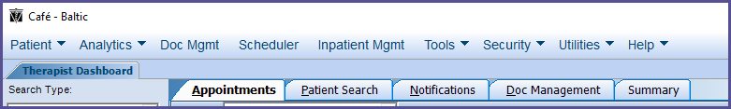

The Scheduler will display.

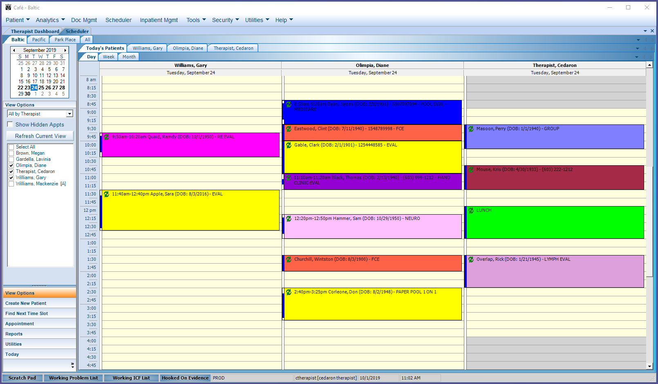

Scheduler Tab

Once the Scheduler is open there will be a new tab at the top of the screen for the Scheduler. The tabs at the top of the screen will allow the user to toggle between the Therapist Dashboard, the Scheduler and any other tabs that are open like Patient Charts.

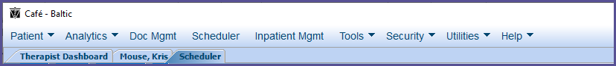

Locations Tab

The tabs directly above the Calendar in the Scheduler will show the organization’s different locations. Schedules at different locations can be viewed and edited by clicking on the locations name.

The ‘All’ tab can also be utilized to view schedules at all locations at once. This tab is read only however, so schedules cannot be edited while on the ‘All’ tab.

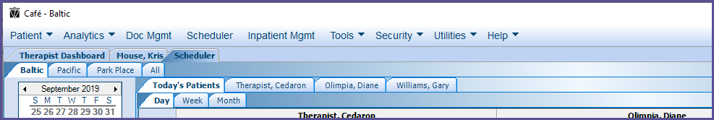

Calendar

The Calendar in the Scheduler allows the user to toggle between specific dates. When the user clicks on a specific date, the schedule will display for that date.

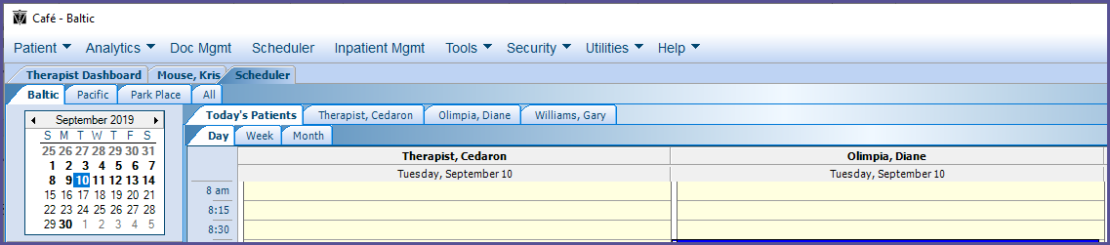

View Options Menu

The View Options Menu gives the user the ability to view the schedule by therapist or by resource. It also allows the user to select and deselect which therapist/resource schedules they would like to see displayed at once.

To change the schedule view from Therapist to Resource or vice versa, click on the dropdown next to All by Therapist/Resource.

Resources are fully customizable by each organization. For example, resources can be things such as specific treatment rooms, a treadmill, a pool, an e-stim, etc. If an organization schedules by resources, it indicates that the resource is being used for a specific appointment, thus notifying others that resource will be unavailable at the time of the appointment.

The Therapist/Resource appointments that display at once can be adjusted by checking and unchecking the box next to their names.

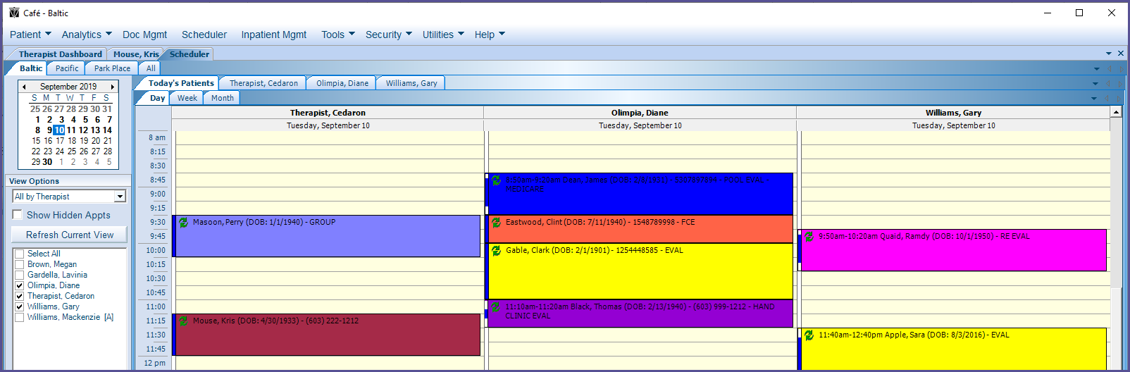

Show Hidden Appointments

Cancelled, No Show and Waitlist appointments will not appear in the schedule unless Show Hidden Appointments in checked. If checked the once hidden appointment will display in the schedule among the other appointments with a text indicator of their status as cancelled, no show, etc.

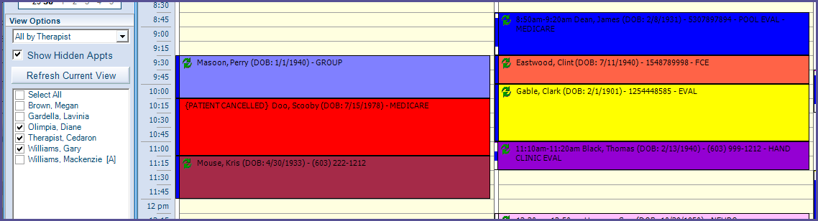

Therapist Tabs

The Therapists whose names are checked will have tab with their name displayed above the schedule next to the ‘Today’s Patients’ tab.

The order of these tabs can be rearranged by dragging and dropping names in the desired order.

These tabs can be used to view a specific individual’s schedule by clicking on the tab with their name. If the ‘Today’s Patients’ tab is clicked, the selected individuals’ schedules will be combined.

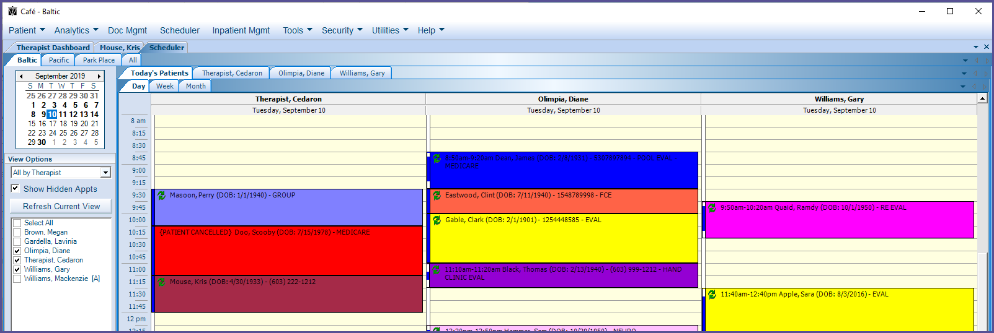

Day, Week, Month Tabs

The Day, Week and Month tabs, directly below the ‘Today’s Patients’ tab, allows the user to toggle between viewing the schedule by individual days, one week at a time or in a month view.

If the ‘Today’s Patients’ tab is selected along with Day, Week or Month, all the individuals that have a check next to their name in View Options will have their schedules combined in the schedule.

To view only one individual therapist’s schedule in Day, Week or Month at a time, click on the tab with their name along with the Day, Week or Month time period tab desired.

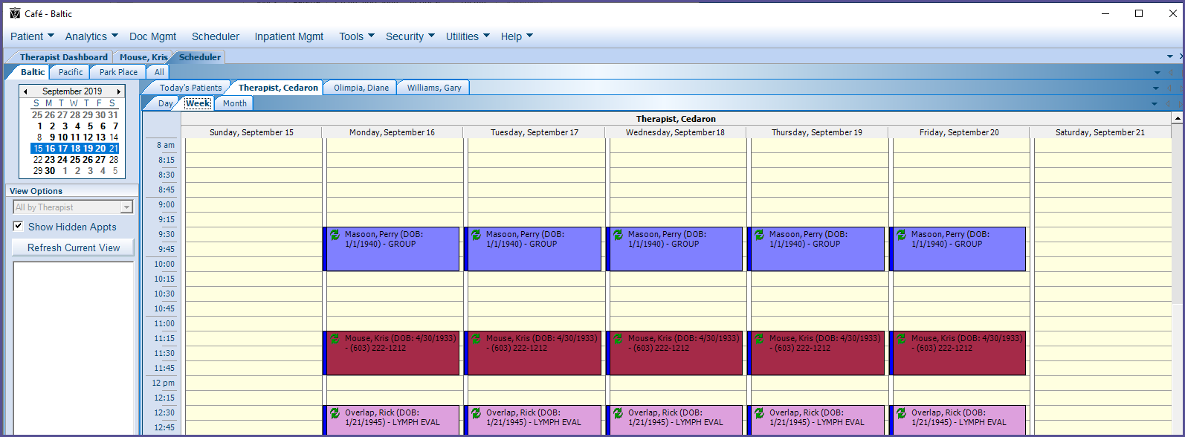

Tab Dropdowns

The tabs for Locations, Therapists and Day, Week, Month can also be toggled between using the dropdowns on the upper right of the Scheduler window.

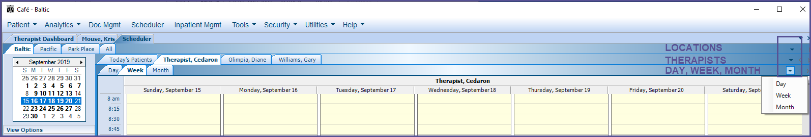

Scheduler Menu

The Scheduler Menu is in the bottom left corner of the Scheduler. The different options to choose from in the Scheduler Menu are (highlighted below):

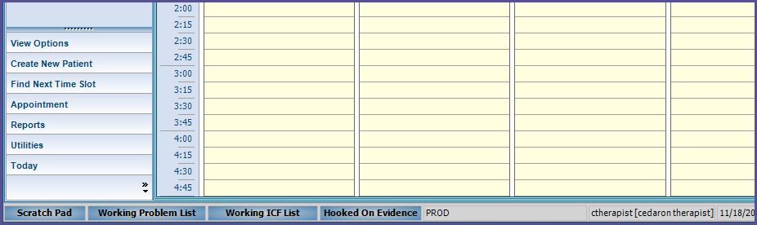

* View Options: Clicking View Options brings back up the View Options Menu, allowing the user to select different therapists and to view the schedule by therapists or by resources.

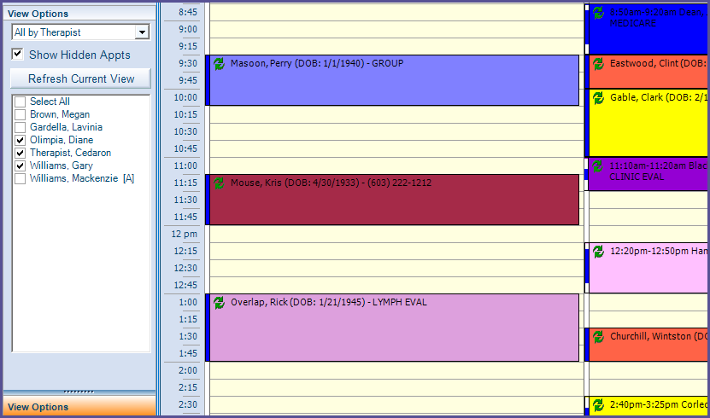

* Create New Patient: Brings up a new tab, allowing the user to create a new patient in Connect.

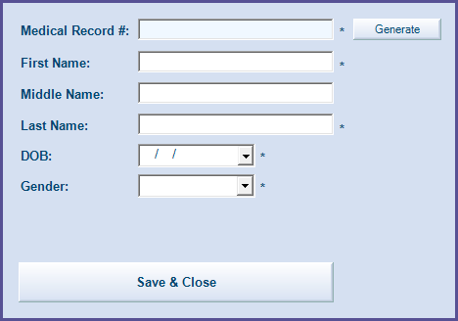

* Find Next Time Slot: Brings up a new window, in which the user can quickly find available time slots to schedule appointments within.

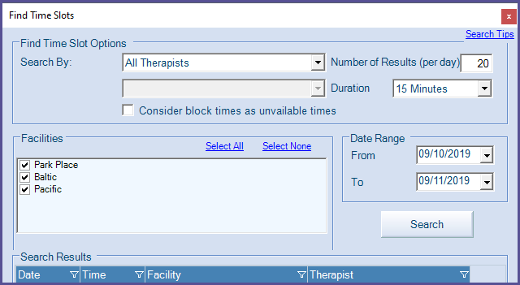

* Appointment: Allows the user to search for a patient from the Scheduler screen and create an appointment by dragging and dropping their name into the schedule.

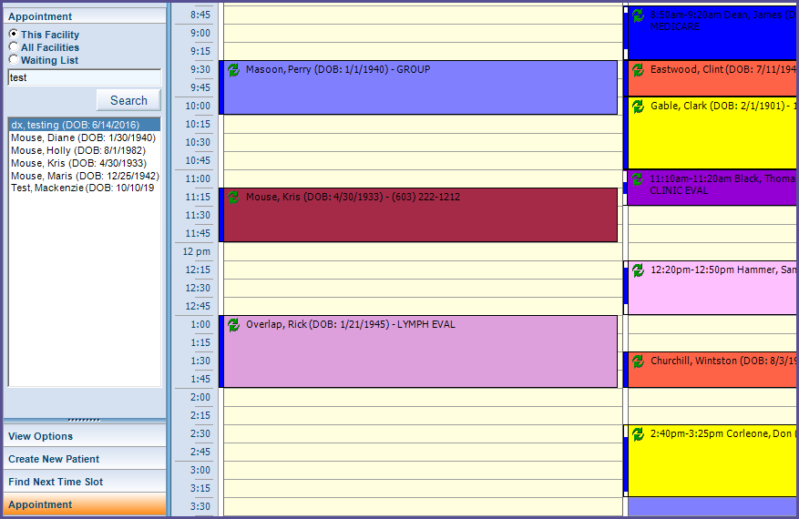

* Reports: Allows the user to generate various reports from the Scheduler. The names of the different available reports are highlighted below.

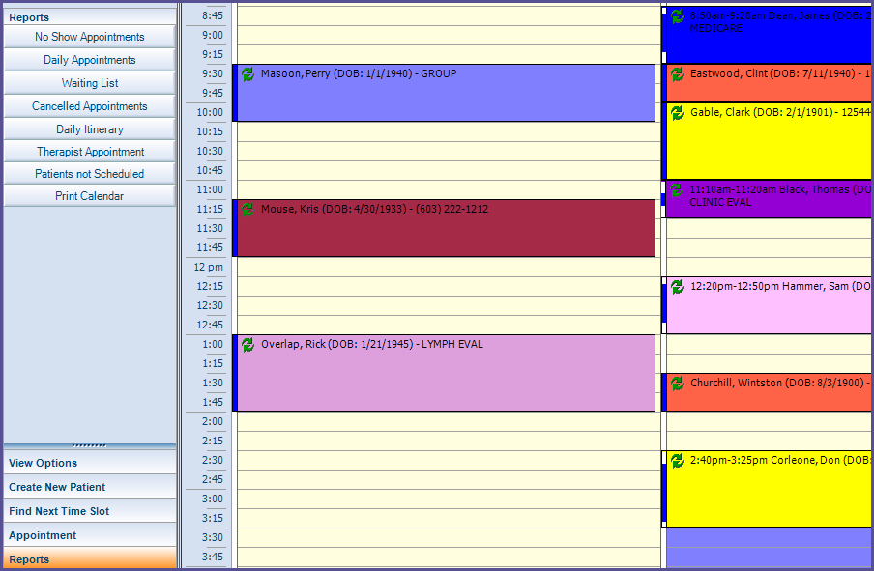

* Utilities: Allows the user to Add/Modify Resources, change the Scheduler Settings and Modify Block Types.

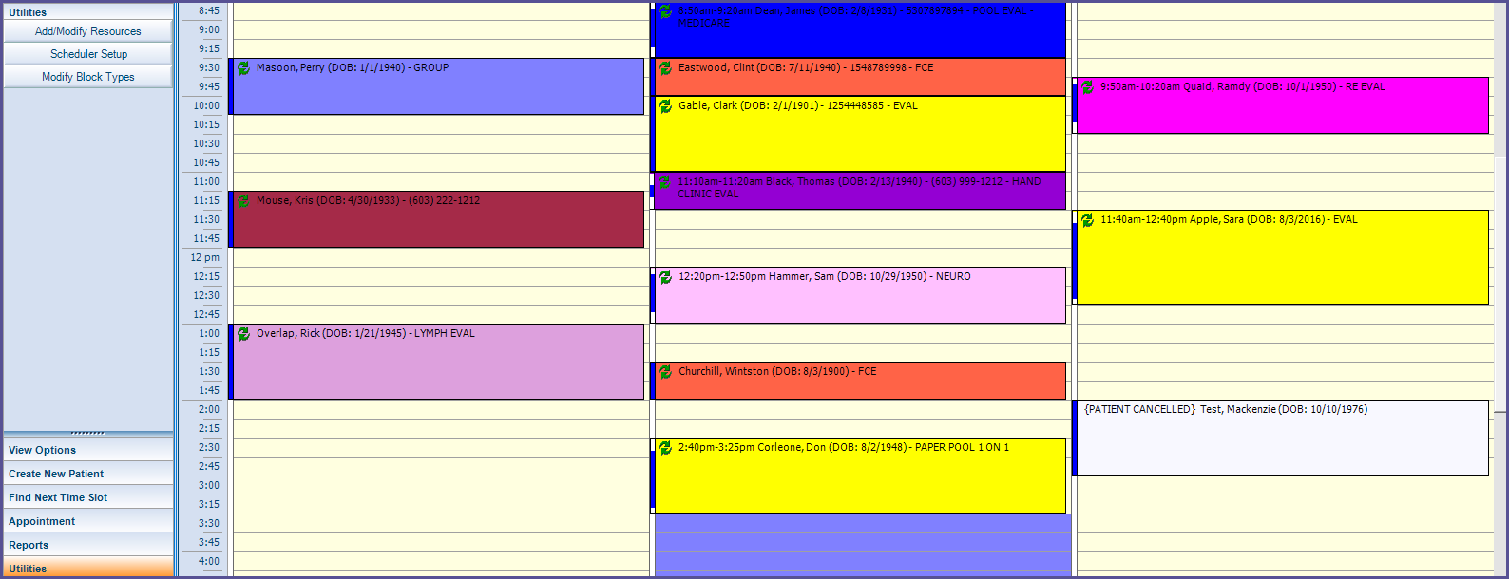

* Today: Clicking on Today brings the schedule view back to today’s date if the user had navigated to a different date on the schedule.

