**Doc Manager Rules**

The purpose of this guide is to help users understand how to complete the Document Manager Rules form.

# **Document Manager Rules**

Document Manager Rules dictate which reports are required to be run, helping to ensure proper documentation and charge captures are completed.

The types of rules that can be created are:

**Visit Based Rules**:

* Initial evaluation rules: With this rule an organization can set which reports alongside with a charge capture need to be completed on every first visit.
  + Example: Require a *PT/OT Initial Evaluation* or a *SLP Initial Evaluation* and *Charge Capture* completed on the **first visit**
* Follow-up visit rules: With this rule an organization can set which reports alongside with a charge capture need to be completed for every visit after an initial visit and before a discharge visit.
  + Example: Require a *daily note* and *charge capture* for all follow-up visits.
* Discharge rules: With this rule an organization can set which reports along with a charge capture need to be completed for a discharge visit.

**Expiration Based Rules**:

* Medicare Progress Report: This rule sets when a Medicare progress report needs to be completed.
  + Example: Require a *Progress Report* and *Charge Capture* to be completed every 10th visit or 30 days.
* Medicare certification/re-certification rule: This rule sets when a Medicare certification/re-certification report needs to be completed.
  + Example: Require a *Medicare certification report* and *Charge Capture* to be completed when the Plan of Care (PoC) expires.
* Non-Medicare/non-worker’s comp. progress report rule: This rule sets when a progress report for non-Medicare/non-worker’s comp patient needs to be completed.
  + Example: Require a *progress report* and *charge capture* to be completed every 30 days.
* Worker’s comp certification/re-certification rule: This rule sets when a certification for a worker’s comp patient needs to be completed.
  + Example: Require a *certification* and *charge capture* to be completed every 30 days.

During implementation, after report builder training, your Cedaron implementation project manager will provider your organization’s lead Connect project manager with the Connect Document Manager Rules form to complete.

# **Completing Document Manager Rules Form**

Below is an example of how the form will look (note: newer versions may have slightly updated formatting):

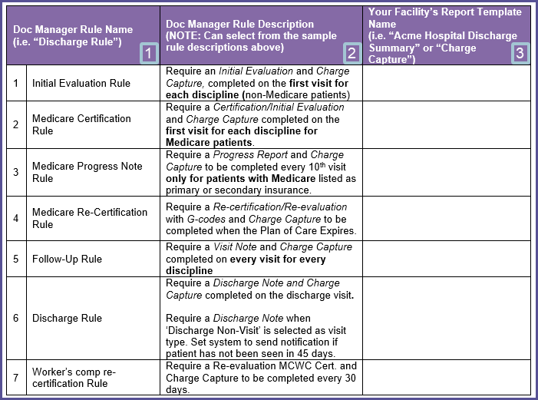

In order to complete the form, fill out each of the 3 columns:

1. Type in a name for each rule. You may use the names shown above or create custom names.
2. Type in the description of the rule. You can use the seven different examples under Visit Based and Expiration Based Rules above as templates for your rules.
3. Type in the names of all your facility’s reports that coincide with the rule being created.
   1. For example: if Acme Hospital is creating an initial evaluation rule and has built separate initial evaluation reports for each discipline they provide (PT, OT and SLP), then the name of each one of those reports needs to be listed in column 3. Any other report that would satisfy your rule, such as a functional capacity evaluation report, would also need to be included in column 3.
      1. Here is an example of how the three completed columns:

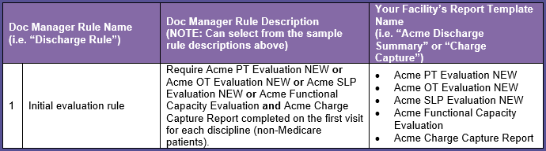

When you have completed the form to include all of the desired rules for your facility, email it to your Cedaron implementation project manager, during implementation, or email it to [support@cedaron.com](mailto:support@cedaron.com) if your organization is already live.

Cedaron’s technical staff will then program your document manager rules into your system.

**\*Important note about document manager rules once they are implemented\***

If your facility edits the name of any of the reports that were entered into column 3 that are used to program your document manager rules

**Or**

Creates a new report that you want included as one of the reports that will satisfy one of your existing rules/create a new rule to coincide with that new report –

Please contact our support team via email at [support@cedaron.com](mailto:support@cedaron.com) with information regarding on what has changed in order to have our technical team update your document rules accordingly otherwise they will not function as expected.