**Using Doc Manager**

The purpose of this guide is to help users understand how to access and use Doc Manager in Connect.

# **Using Document Manager in Connect**

Reminders will be triggered in Connect when documents for the rules that are created are either past due, due today, or upcoming.

For example: Using our initial evaluation rule from above, which requires both an initial evaluation report to be run as well as a charge capture to be completed, if either one of these reports were not completed, there will be a reminder in **Doc Management** that they need to be completed.

**Accessing Doc Management:**

1. From the *default* therapist dashboard by clicking on the **Doc** **Management** tab. (This will not apply if your organization has a custom therapist dashboard without the doc management tab)
2. By clicking on **Doc Mgmt** in the menu bar across the top of Connect.

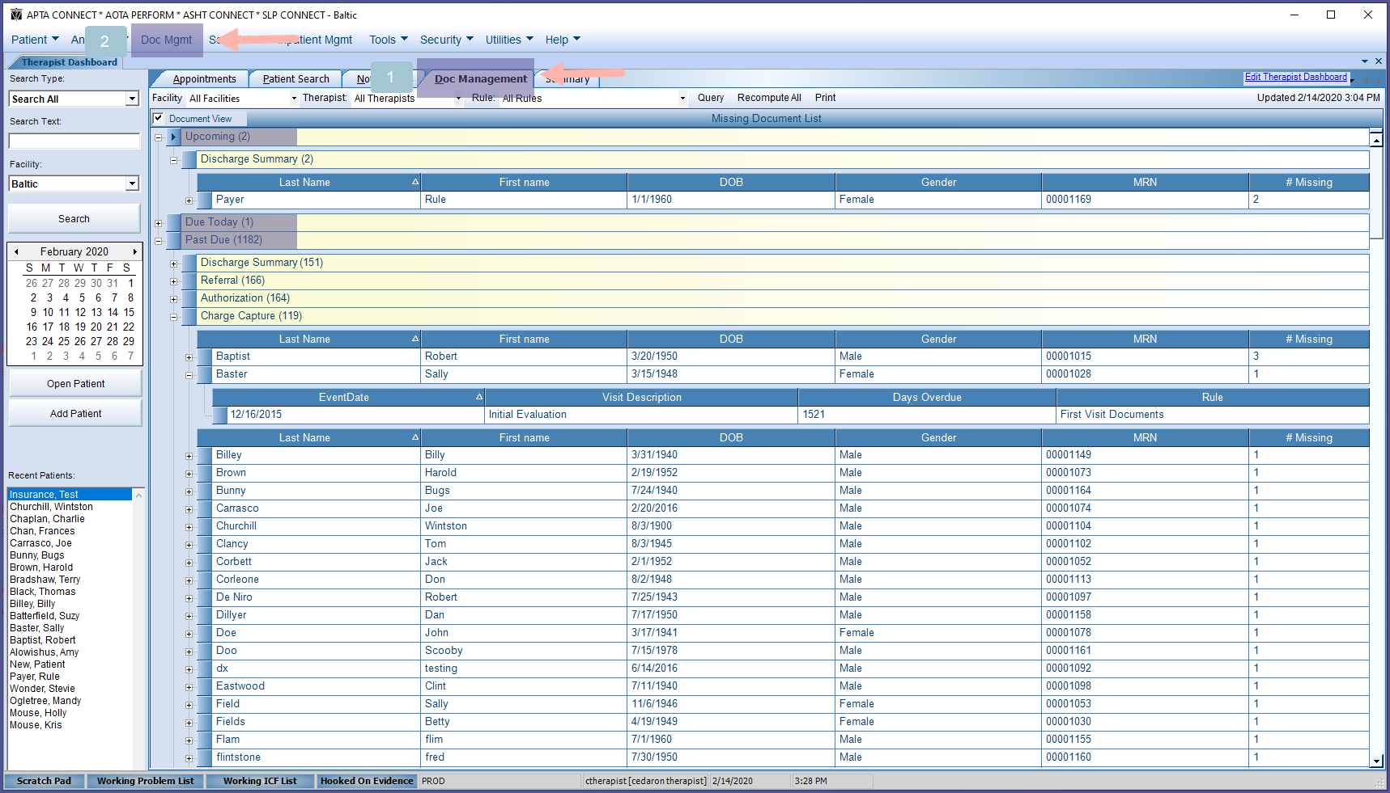

Once on Doc Management, there will be three different date categories:

1. Past Due
2. Due Today
3. Upcoming

Each date category can be expanded by clicking the **+** symbol next to it to show a list of the different document types that need to be completed.

The document categories that load can also be expanded by clicking the **+** symbol next to it.

In the example below **Charge Capture** is expanded and we can see all the past due charge captures by patient.

Clicking the **+** symbol next to a patient’s name expands and shows the visit dates on which that specific document is due.

In the example below we can see that a charge capture for patient Sally Baster was due on 12/16/2015.

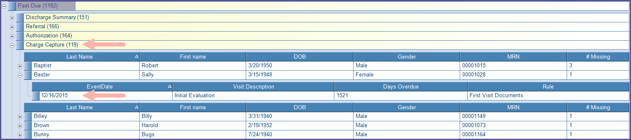

**Sorting and Filtering Doc Management Items:**

The list of names that loads after expanding the document type category can be sorted by any column (last name, first name, DOB, Gender, MRN, # Missing) by clicking on the desired column name to have items listed in an ascending or descending order.

In the example above, patients are listed in alphabetical order by last name.

In the example below, patients are listed in alphabetical order by first name.

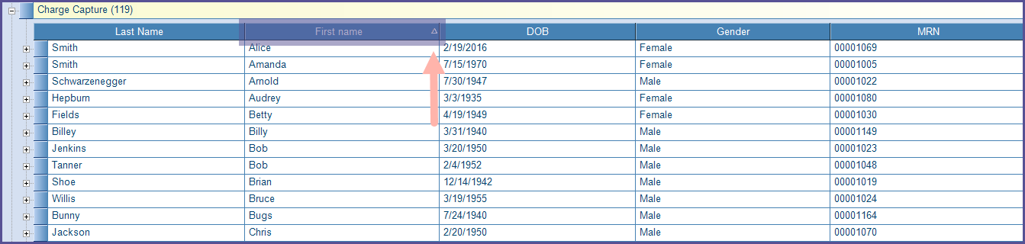

The order of columns can also be changed by clicking on a column header (last name, first name, DOB, Gender, MRN, # Missing) and dragging and dropping the selected column in the desired order.

In the example below, MRN has been moved in front of the last name column.

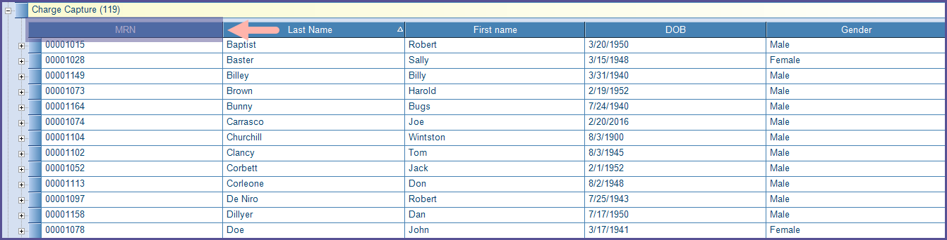

Users can also filter items in Doc Management using the query menu at the top of the Doc Management window (highlighted below).

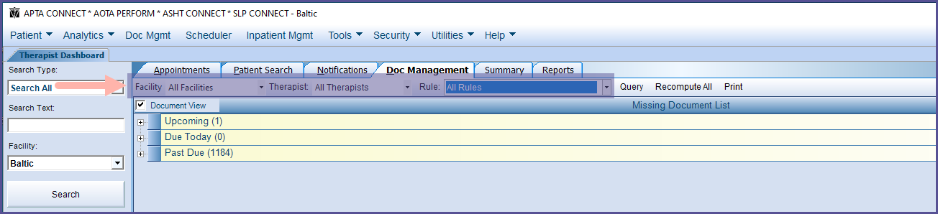

Users can filter Doc Management items by:

1. Facility
2. Therapist
3. Rule

Note* - Only admins will be able to filter by therapist.

After selecting the applicable query options, click **Query** to load the filtered results.

The results in the example below are filtered for a specific facility and specifically for the Discharge Documents rule.

There are only 2 past due documents when we filter by this criterion, versus the 1184 past due documents in the example above where query was not used.

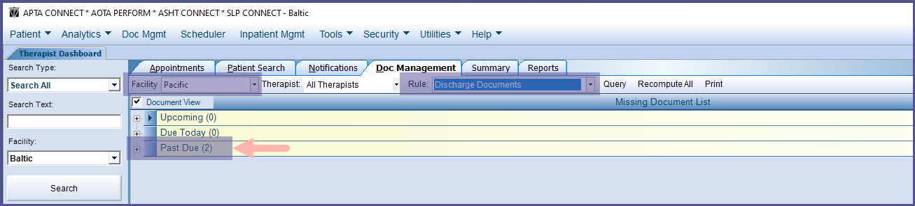

**Completing Doc Management Items:**

In order to clear an item from Doc Management, the necessary report needs to be completed the patient listed.

Once the **+** symbol next to the name is expanded, the date on which the corresponding document needs to be completed will display.

In the example below, we can see that an *initial evaluation report* still needs to be completed for patient, Bugs Bunny for their visit on 12/02/2019.

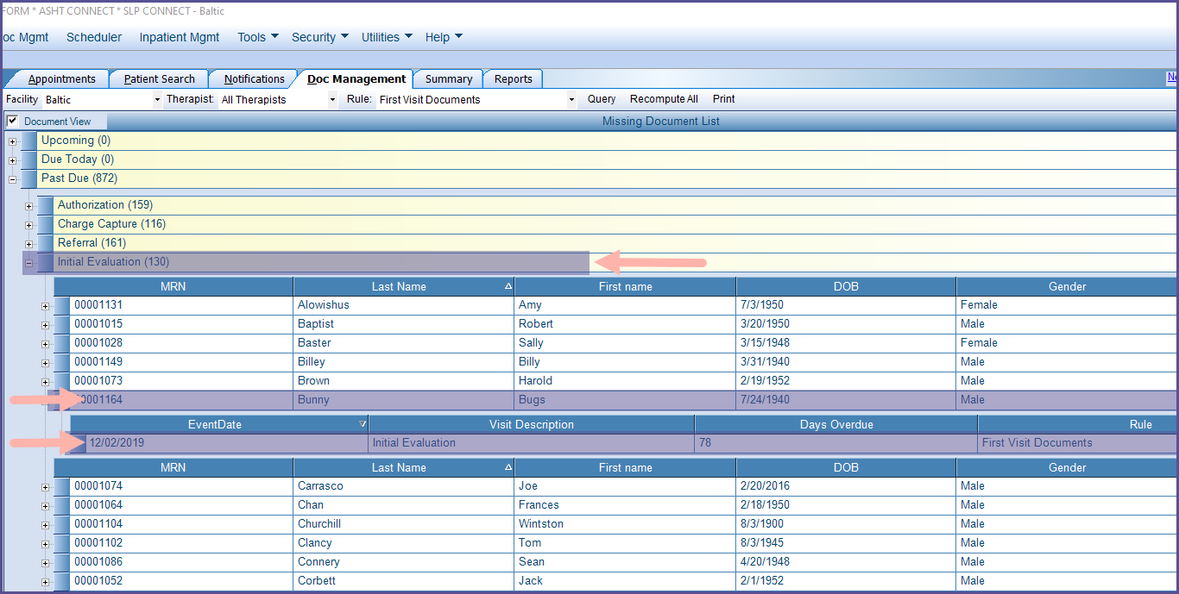

Double clicking anywhere on the row with the event date, will open the patient’s chart on the visit date that the report needs to be completed for.

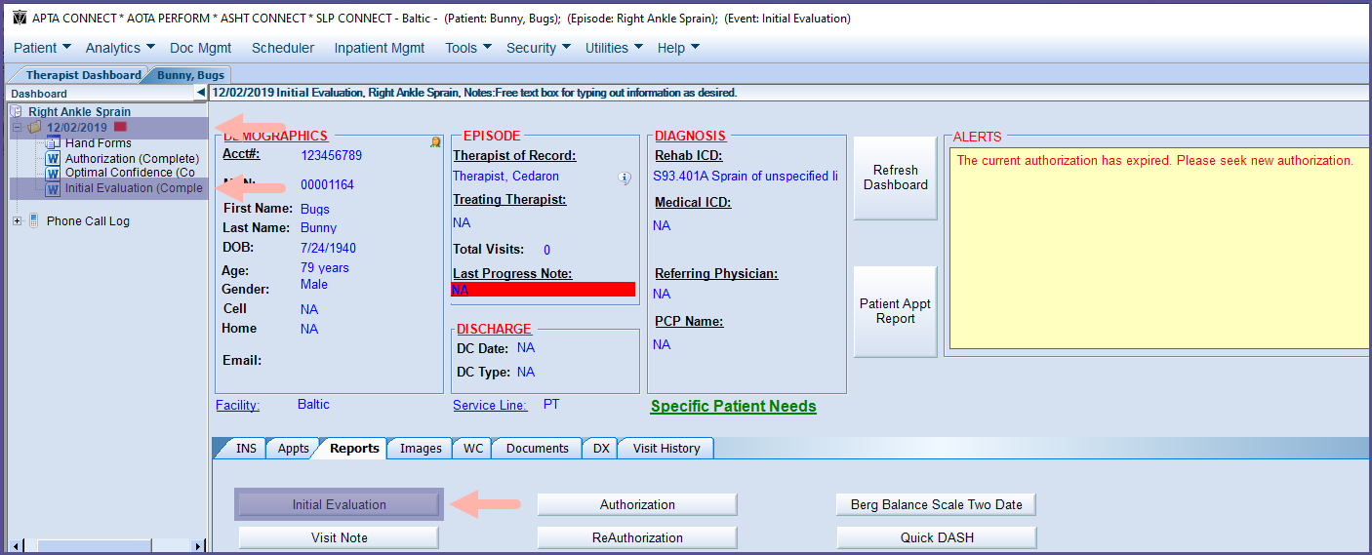

Once the required report is completed, in the above example it is an initial evaluation, go back to Doc Management.

The item will still be listed. There is one more step that needs to be completed for the item to be removed –

Click **Recompute All** across the top of the Doc Management window.

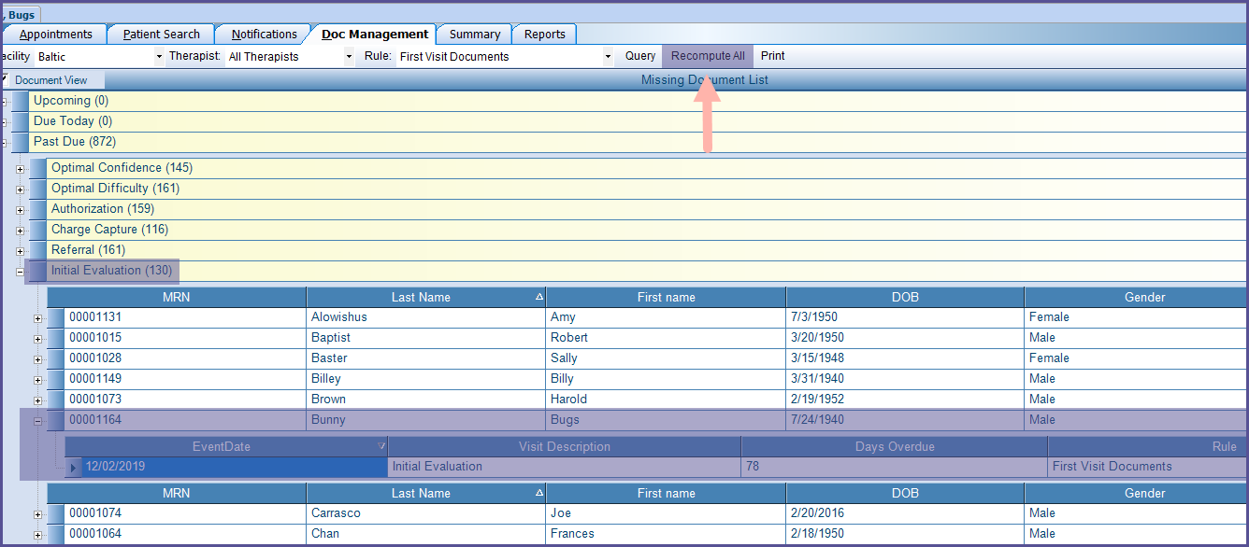

In the example above you can see the Initial Evaluation for Bugs Bunny is still listed as needing to be completed and there are 130 total initial evaluations outstanding.

After Recompute All is clicked, the completed items will be removed from Doc Management. You can see below that Bugs Bunny has been removed from the list of patients with past due initial evaluations and there are now 129 total initial evaluations outstanding.

