**Scheduler Utilities**

The utilities in Scheduler has options for:

* Add/Modify Resources
* Scheduler Setup
* Modify Block Types

# **Accessing Utilities in Scheduler**

To access Scheduler Utilities, first open your Scheduler by clicking on **Scheduler** at the top of your screen in Connect.

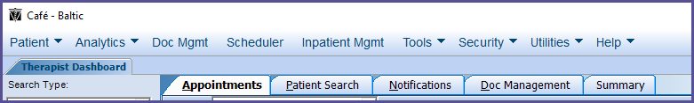

Then in the Scheduler Menu (in the bottom left corner) click on Utilities.

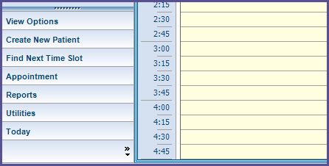

# **Utilities**

The available reports will display in the middle of the navigation pane.

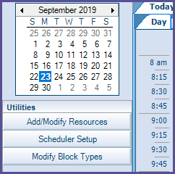

**Add/Modify Resources**

When *Add/Modify Resources* is clicked, a box appears that allows the user to add or delete resources that can be scheduled (such as a pool, treatment rooms, ultrasounds, x-ray machines, treadmills, etc.).

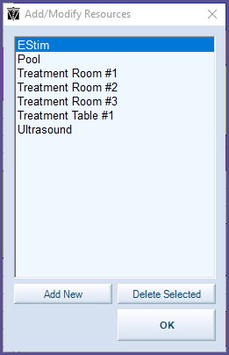

When Add New is clicked, a box appears that the user can enter the name of a resource into the text box then press OK to save the new resource.

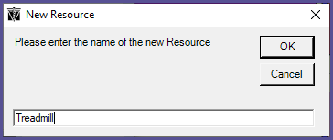

To delete an existing resource, click on the resource to be deleted, the click Delete Selected. A confirmation Delete Resource box will appear. Click Yes to delete the resource.

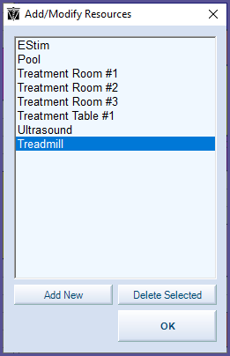

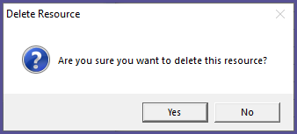

**Scheduler Setup**

Scheduler Setup gives users the ability to customize Shift Schedule, Block Times, Special Activities, and Scheduler Settings.

There are 2 options for accessing Scheduler Setup:

* Option 1: Click on *Scheduler Setup* in the Utilities menu.

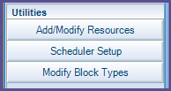

* Option 2: Right click anywhere in the schedule, then click on *Edit Shift Schedule and Block Times…*

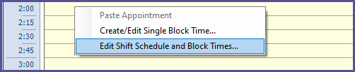

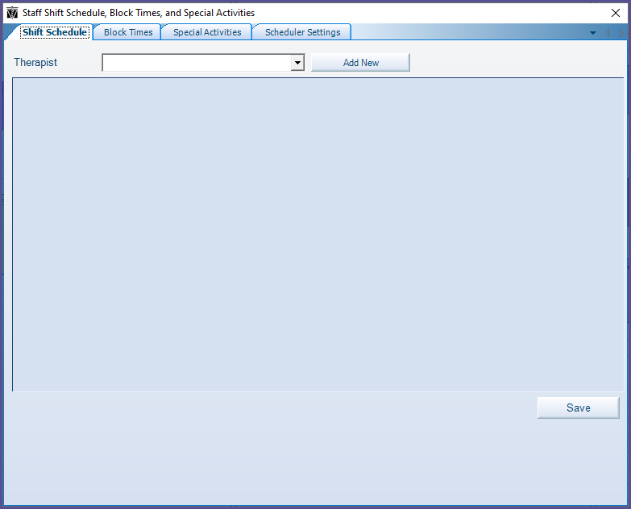

**Shift Schedule**

Shift schedule allows users to customize the availability of each individual therapist. When a therapist has a shift schedule set, any time outside of the shift schedule time will be greyed out in the schedule. If no Shift Schedule is set, the therapist’s schedule will either

To add a therapist’s shift, select a specific therapist from the therapist dropdown, click **Add New** and a new blank row will appear. Select the **Day Of Week** from the dropdown. Enter in the **Start Time** and **End Time**. Type or select the **Effective Date**. **End Date** is optional. Then click **Save**.

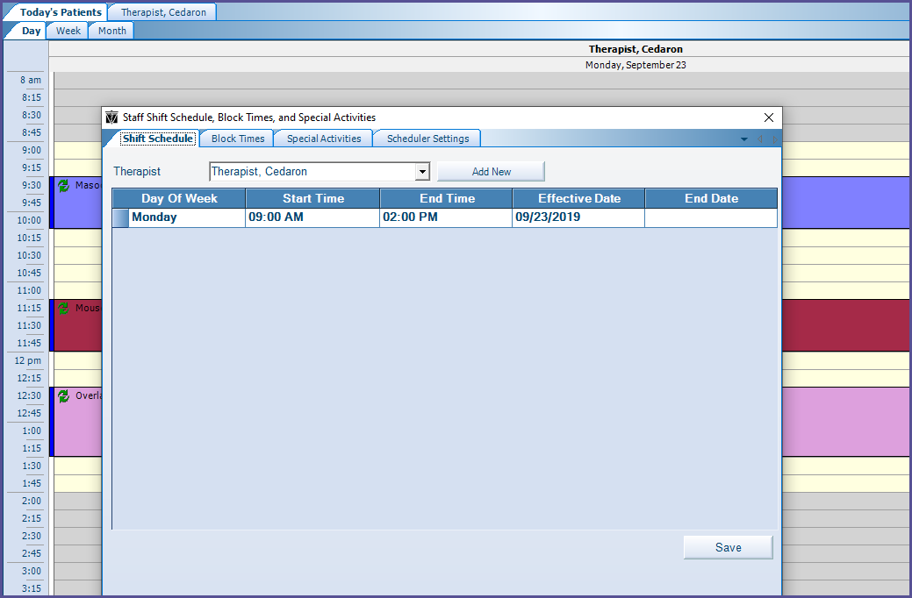

**Block Times**

Block times are used to set the default appointment type and duration for a span of time.

From Scheduler Setup, select the Block Times tab to be able to set block times for specific therapists.

The fields are all the same type as for **Shift Schedule** and entered the same way, except for **Block Type**, which can either be entered by typing into the cell or using the drop-down. The **Block Type**s listed can be customized in **Modify Block Types** (Modifying block types is covered in the latter part of this guide)**.** Enter the necessary information then click **Save**.

Checking the box for *View past block times* allows block times shows past block times in the list.

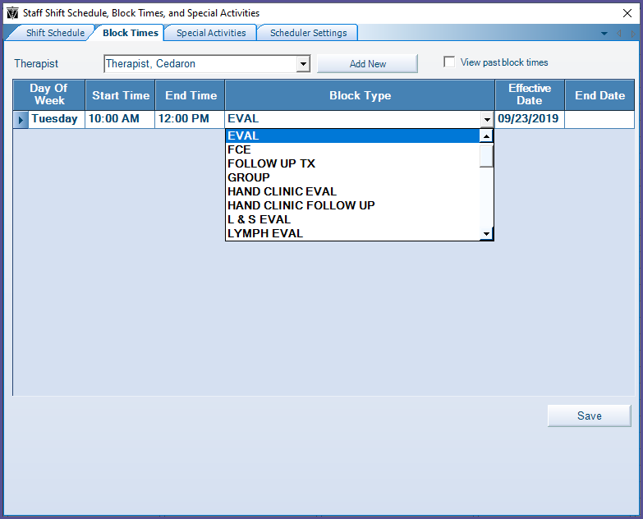

The user can add as many block times as needed by clicking **Add New** to add a new row.

**Day of Week**, **Start Time**, **End Time**, **Block** **Type**, and **Effective Date** are required fields. **End Date**is optional.

The scheduled block time will appear in the therapist schedule and will be represented by the color assigned to that block type (See below the sky-blue block).

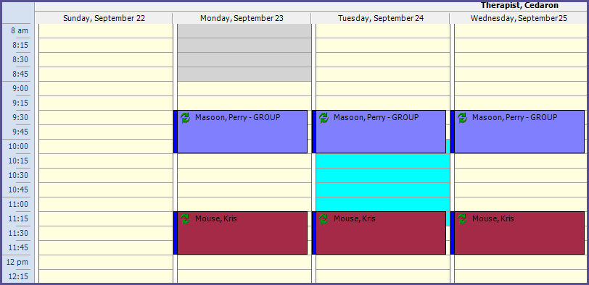

**Special Activities**

The **Special activities** tab allows the user to indicate times when therapists are not available (e.g.: scheduled lunch time or meetings).

From Scheduler Setup, select the **Special Activities** tab to set special activity times.

**Start Time**and **End Time**allow the user to input a date and time, either by typing in or using the dropdowns. By clicking the **Reminder** checkbox, a reminder dialog will pop up in Connect at the length of time prior to the activity that is selected from the drop-down.  Scheduler must be open for the reminder to open on the therapist’s screen.

**Reason** has a text box into which a reason for the unavailable time can be typed. **Label**allows the span of time to display color coded in the columns to indicate the nature of the **Special Activity**. The list of available **Label**s can be edited by clicking the **Customize** button. A dialog box appears that allows the user to edit **Name**and **Color**or delete rows in the same manner as **Modify Block Types** or add a **Label** by clicking **Add New Item**.

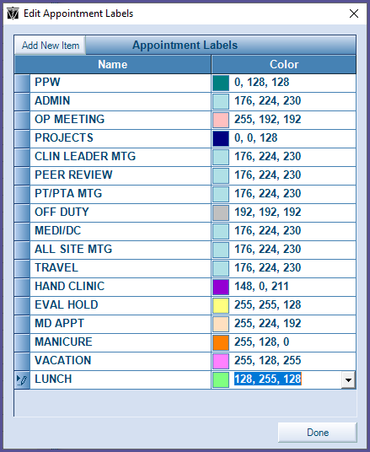

If a **Label** is selected from the drop-down, the label will automatically overwrite anything in the **Reason** input box. If both a **Label** and custom **Reason** are desired, then the **Reason** must be entered after the **Label** is selected.

Therapists to whom the **Special Activity** applies can be selected from the checkboxes.  If the dialog was accessed via the **Scheduler Menu Utilities**button, then none of the therapists will be checked. The therapists’ names do not appear in alphabetical order, and if there are more names than fit, a scroll bar will appear at the bottom of the box of names that can be used to scroll through the names. The **All/None** checkbox works as a toggle to select all of the therapists or none of the therapists.

If the **Special Activity** is a recurring event, **Daily**, **Weekly**, or **Monthly** recurrence can be defined by checking the **Recurrence** checkbox and selecting the appropriate radio underneath. When the **Daily**radio button is selected, the user can type in the frequency of the event in number of days.

* When the **Weekly**radio is selected, the user can select the checkbox of the day or days of the week on which the event occurs.
* When the **Monthly** radio is selected, the user can select the day of the week on which the event will occur, and they can select whether it is the first, second, third, fourth or fifth instance of that day within the month that the event will occur.
* The user can also choose between ending the event’s recurrence after a specified number of occurrences and ending on a specified date by selecting one of the two radios at the bottom. If the **End after** radio is selected, the user set the number of recurrences. If the **End by**radio is selected, the user can type a date or select from the calendar drop-down.

The buttons at the bottom: **Save & New**, gives the option of saving the activity and creating another; **Save,** saving and closing the scheduler setup box; and **Cancel**, cancelling the changes.

**Start Time**, **End Time**, and **Therapists** are required to create a Special Activity.

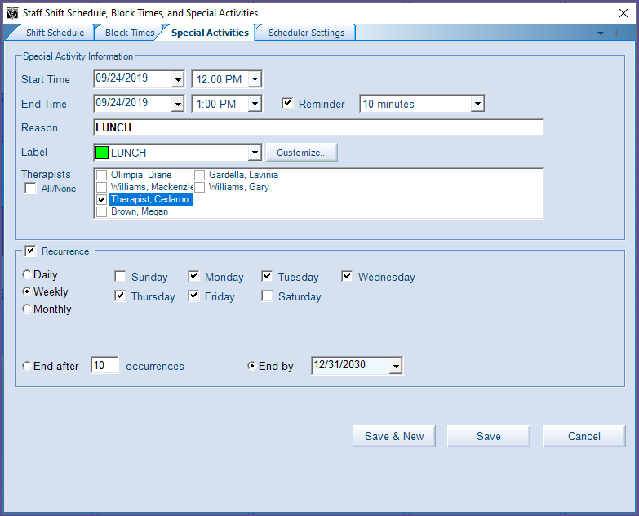

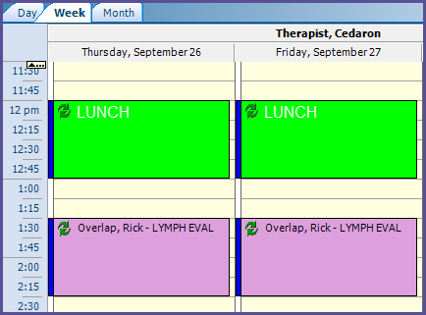 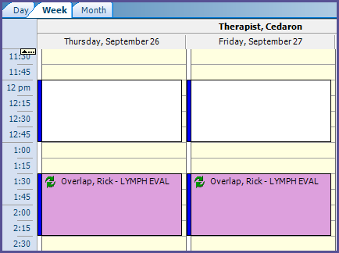

**VS**

The **Reason** entered when creating the special event will display in the calendar once the special event is created and the color of the **Label** selected (e.g.: the green color in the left picture with “Lunch”). If a **Reason** is not entered the special activity on the schedule will not have any writing in it and if a **Label** is not selected the box on the schedule will be white (see above).

**Scheduler Settings**

The **Scheduler Settings** tab allows the user to change the look and feel of the scheduler. These settings only apply to the logged in user.

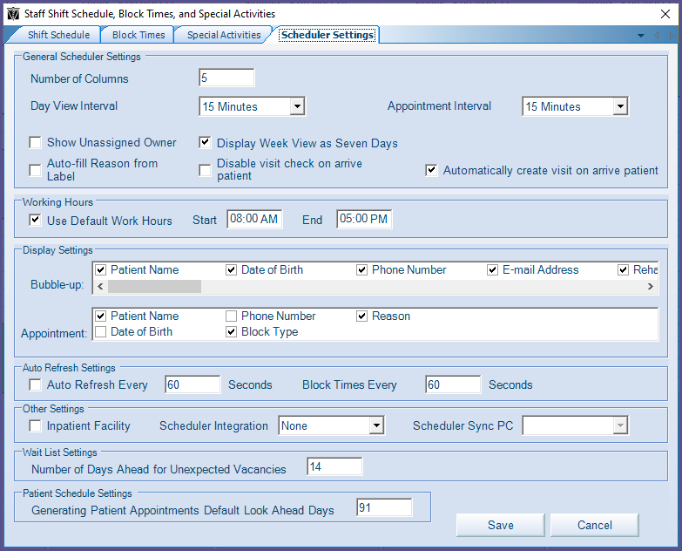

General Scheduler Settings

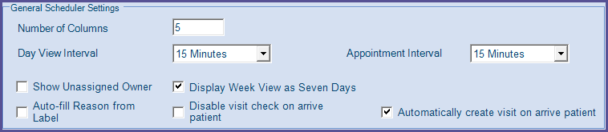

* **Number of Columns** sets the maximum number of columns that display. The desired maximum Columns viewed at once can be typed in. When there are more columns to display than the number set in **Number of Columns**, a scrollbar will appear at the bottom of the columns to scroll over to the rest of the columns.
  + Example of schedule view with Number of Columns set to 5:

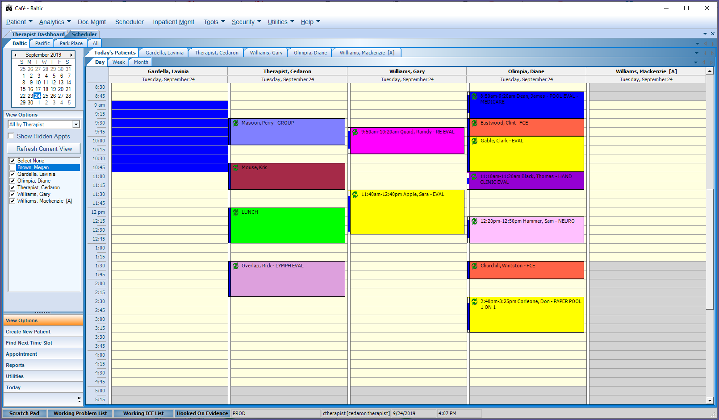

* **Day View Interval** drop-down will change the time increments that the day is sectioned into, displayed in the Therapist Scheduler Columns.
  + Example of Day View Interval set to 15 minutes versus 5 minutes:

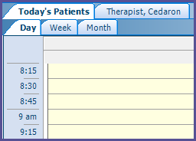 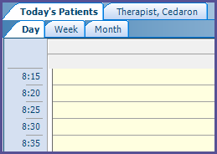

**VS**

* **Appointment Interval** sets the default appointment length when creating new appointments. Every time the user creates a new appointment, the length of the appointment will automatically be set to the Appointment Interval selected in Scheduler Settings but this can be overridden manually or by an assigned block type.
* **Show Unassigned Owner** allows the user to schedule an appointment without assigning the patient to a specific therapist. This will add a column to the Scheduler window for Unassigned Owner appointments.

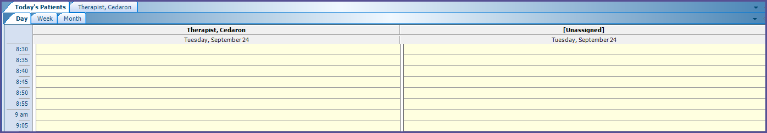

* **Display Week View as Seven** Days changes the weekly schedule view from block to a columnar view.
  + Block View (Display Week View as Seven **NOT** **checked**):

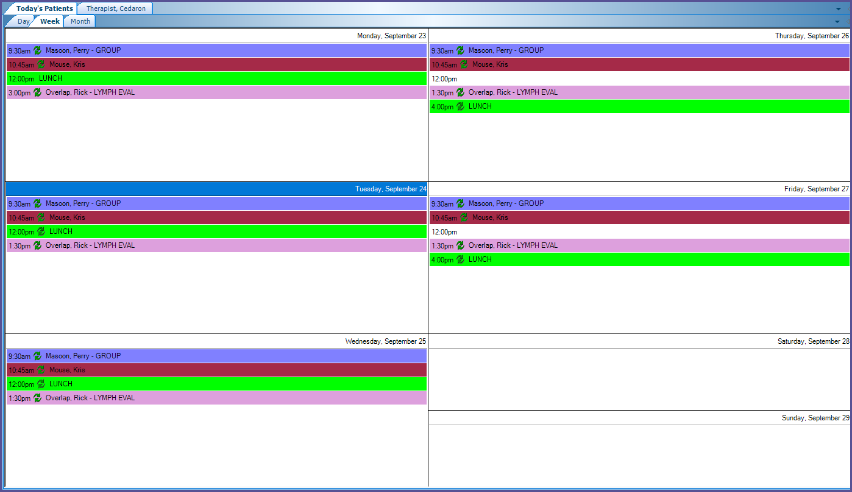

* + Week View (Display Week View as Seven **checked**):

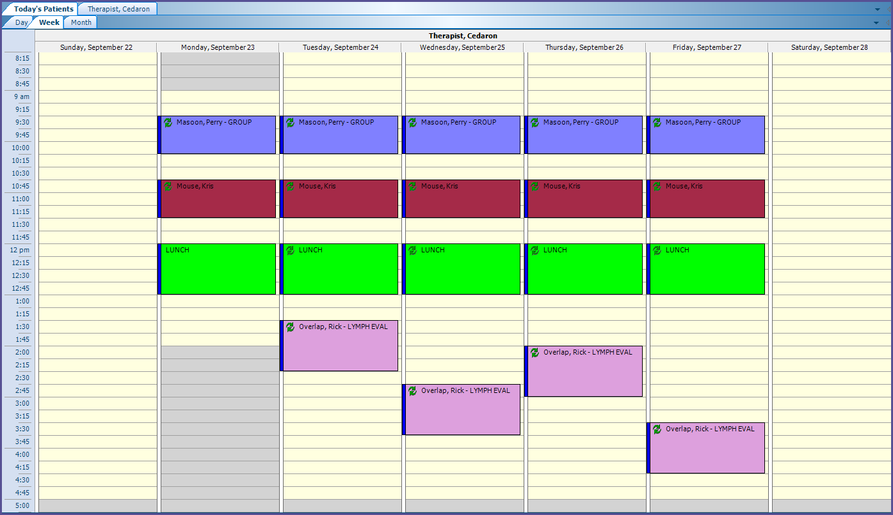

* **Display time labels on both sides**, when checked, displays time labels on the right side of the schedule as well as the left side.

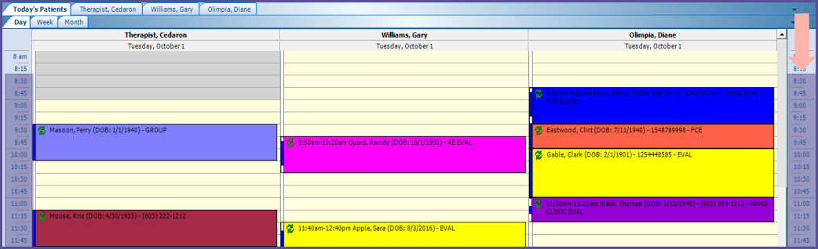

* The checkbox for **Auto-fill Reason from Label** toggles whether, when creating a New Appointment or editing Appointments, an appointment reason is populated when the user selects a label for the appointment.
* The checkbox for **Disable visit check on arrive patient** toggles whether a dialog box appears when a patient is arrived for an appointment to verify that a visit is assigned for the appointment.
* The checkbox for **Automatically create visit on arrive patient** toggles whether a visit is automatically created when a patient is arrived [This checkbox can only be toggled when the checkbox for **Disable visit check on arrive patient**is unchecked (thereby enabling **visit check**)]. If Automatically create visit on arrive patient is checked, then a visit will be automatically created, and the visit check dialog box will not appear unless there are multiple visits to choose from.

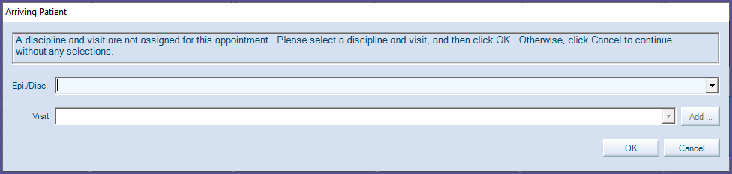

Working Hours



* **Use Default Work Hours** allows the user to set the default working hours for the clinic. The default work hours will be visible on the Scheduler Screen (as the yellow region of the schedule). This may be overridden on an individual therapist basis in the Shift Schedule tab.

Display Settings

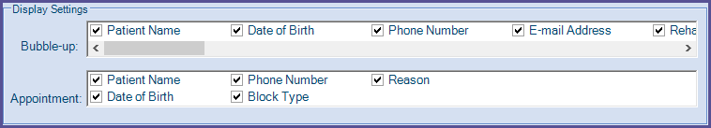

* **Bubble-up** settings control what the user will see when they hover over an appointment in Scheduler. Select or deselect fields based on user preferences.

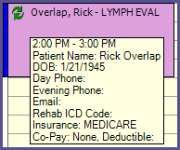

* **Appointment** settings control what the user will see visibly about an appointment on the Scheduler screen.

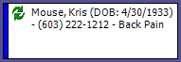

Auto Refresh Settings



* **Auto Refresh Settings** allow the user to set their Scheduler to automatically refresh the schedule on a regular basis so that the most current information is always visible. This is especially important if multiple people are scheduling patients at one time.

Other Settings



* Select the Inpatient **Facility** box if using Connect for inpatient scheduling.
* **Scheduler Integration** allows users to sync their Connect schedule with their Outlook calendar. To use this feature, select Outlook from the Scheduler Integration drop down and then select the appropriate **Scheduler Sync PC** from the dropdown.

Wait List Settings



* **Number of Days Ahead for Unexpected Vacancies** is not currently used in Connect.

Patient Schedule Settings



* **Generating Patient Appointments Default Look Ahead Days** presets the number of days for the ‘Generate Patient’s Schedule Appointment (word)’ from Scheduler (when you right-click an appointment on the schedule).

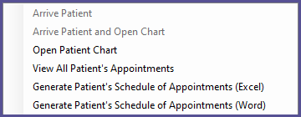

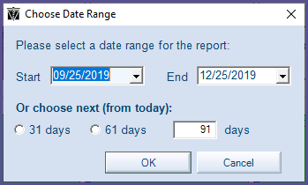

**Modify Block Types**

When Modify Block Types is clicked, a box appears that allows the user to add or delete Block Types. Block Types allows for standardization in appointment types and length of appointments, (e.g.: Initial Evaluation, Discharge, etc.).

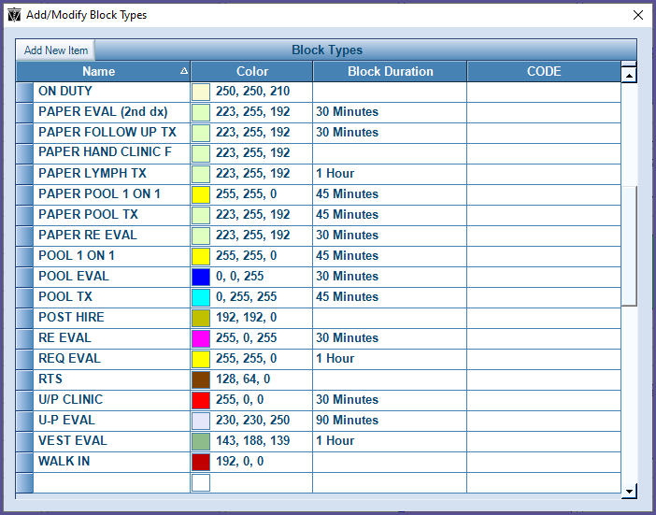

To add a block type:

1. Click Add New Item.
2. A new row will appear.
3. Provide a name for the block type.
4. Provide a color for the block type which will display on the Scheduler screen for an appointment if that block type is selected.
5. Provide a block duration for the block type which will update the end time of the appointment when the block type is selected (this can be overwritten manually).
6. If you are using the Scheduler Interface, provide the CODE (if there is an exact match) so the appointment type can populate the block type in Connect.
7. Close the *Add/Modify Block Types* window.

To modify a block type

1. Select the row of the block type you wish to edit.
2. Edit any fields necessary.
3. Close the *Add/Modify Block Types* window.

To delete a block type:

1. Click *Modify Block Types*.
2. Select the row of the block type you wish to delete.
3. Select delete on your keyboard.
4. Warning: Deleting the block type will delete this type from any existing appointments. Click Yes to continue deleting the block type.
5. Close the *Add/Modify Block Types* window.