**Patient Dashboard Alerts**

The Alerts feature in Connect provides users with patient alerts based on insurance rules and other requirements such as missing information, etc. The Alerts feature also allows users to type in free text notes directly onto the patient’s dashboard that can be viewed and edited by users accessing that patient’s chart.

This guide provides an overview of the different alerts settings in Connect and how to enter in and edit free text in the alerts box.

The Alerts box on the Patient Dashboard shown in this training is the Connect default. A given organization’s Alerts configuration may be different due to ability to customize,

# **Alerts**

To view and create alerts on a patient’s dashboard, first begin by opening a patient’s chart.

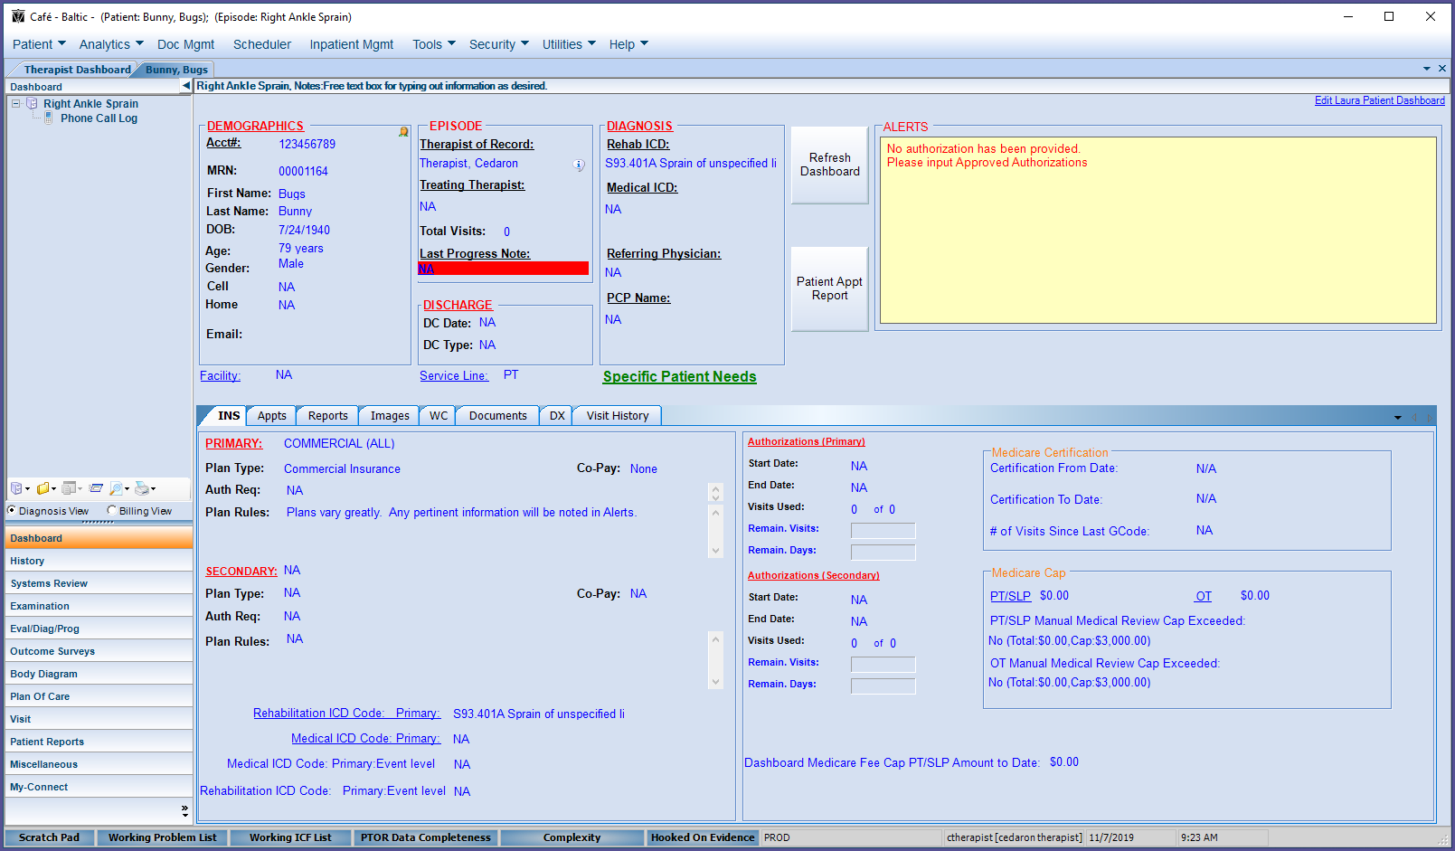

Once a patient’s dashboard is opened, the alerts box will be visible in the upper right area (highlighted above).

# **Alerts Settings**

For the users who have access to change system settings, there are different alerts settings that can be toggled.

To access the Alerts Settings, Click on **Utilities** in the menu bar across the top of Connect then click on **System Settings** in the dropdown.

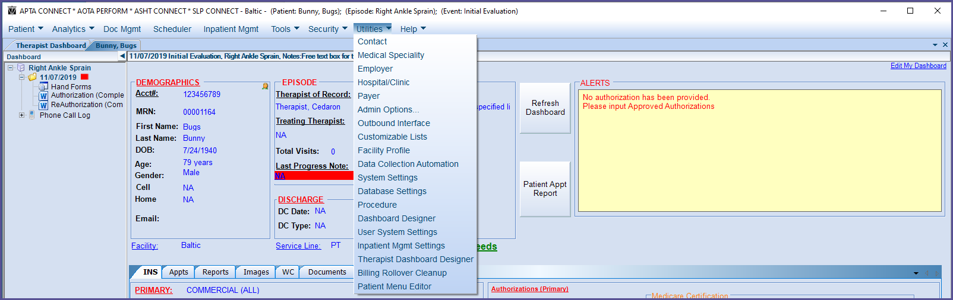

The System Settings box will open.

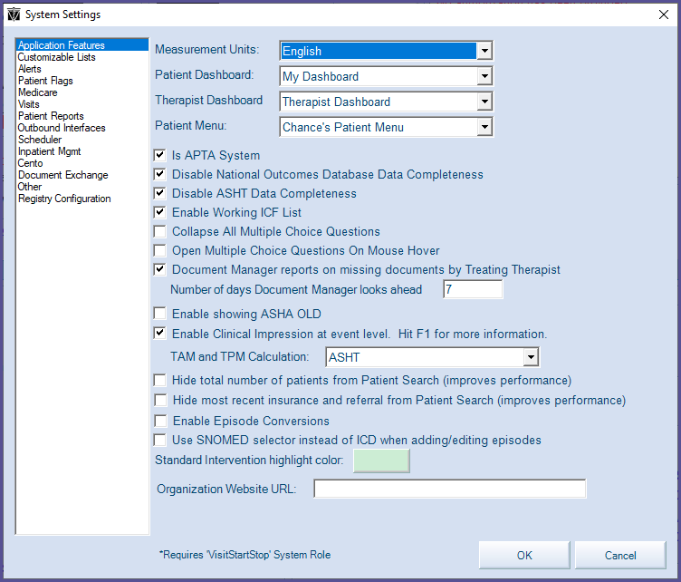

There are patient dashboard alerts settings under **Application Features** and **Alerts** (highlighted above).

**Application Features**

* Disable National Outcomes Database Data Completeness – By default, the box next to this setting will be checked. If your organization participates in the National Outcomes Database, unchecking this will create alerts in the patient dashboard for all the different information fields that are required to be submitted for the NOD.

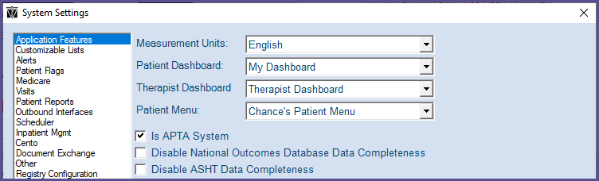

Example of the alerts that will display in the alerts box:

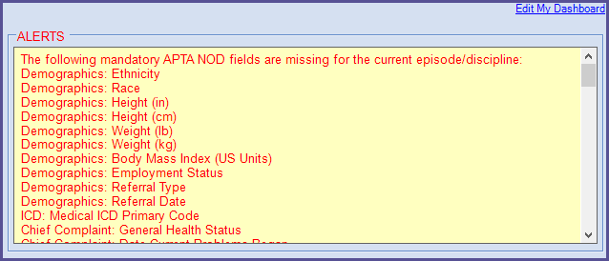

As each required piece of information for the NOD is completed, the corresponding alert will disappear.

This setting helps to ensure all the required NOD information is completed fully.

**Alerts**

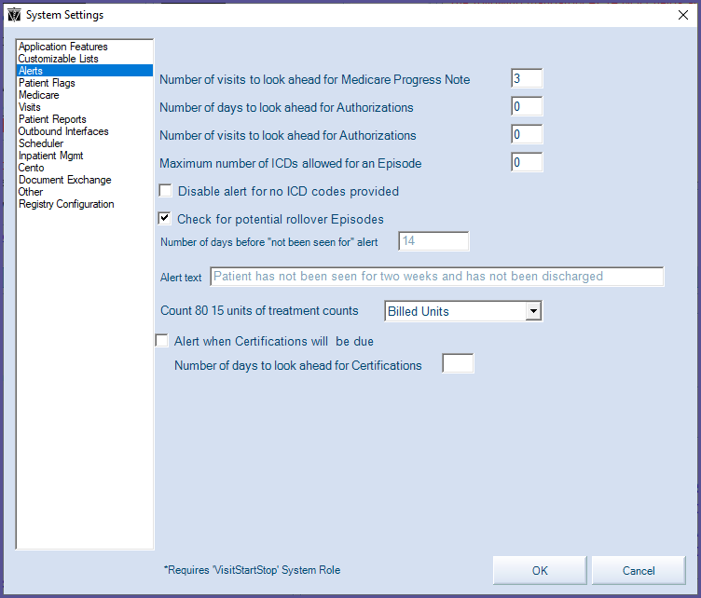

* Number of visits to look ahead for Medicare Progress Note – The number set here will let the user know a set number of **visits** in advance that the patient’s Medicare Progress Note will be due.
* Number of days to look ahead for Authorizations – The number set here will let the user know a set number of **days** in advance if the patient needs new authorization.
* Number of visits to look ahead for Authorizations – The number set here will let the therapist know a set number of **visits** in advance if the patient needs new authorization.
* Maximum number of ICDs allowed for an Episode – If your organization has a maximum number of ICDs allowed per episode, that number is set here. If you do not have a limit, leave this box blank. The default is zero, which equates to unlimited number of ICDs per visit. This setting does not create an alert in the ALERTS box in the patient dashboard like the other settings. It instead causes an alert to trigger after Lock & Push is clicked when completing a charge capture for a visit if the number of ICD codes exceeds the set maximum.
* Disable alert for no ICD codes provided – By default, the system will provide an alert in the patient dashboard if there have not been ICD codes provided for a patient. To disable this automatic alert, check this box.
* Check for potential rollover Episodes – Selecting this setting will give users an alert if a new account has been registered and should be reviewed to manually merge with another episode. This setting only applies for organizations with an ADT interfaces. This setting also does not create an alert in the alerts box on the patient dashboard. It triggers a popup notification when a patient chart is opened if the Connect has identified a potential rollover.
  + If the user identifies that the episode should be rolled over, this can be done so by right clicking on the episodes in question and then selecting from “Roll over to.” If it should not be rolled over, the episode can be rolled over by clicking on “Edit Episode.”
* Number of Days before “not been seen for” alert – This setting is a helpful indicator that the patient should be scheduled for another visit or discharged from treatment. By default, this is set to alert after a patient has not been seen for 14 days.

This setting will not create an alert in the ALERTS box. It will instead trigger a notification to appear in the Notifications tab on the Therapist Dashboard.

* + Alert Text – This alert text field allows organizations to define the text that notifies if a patient has not been seen for “x” days. This is a free text field and by default reads, “Patient has not been seen for two weeks and has not been discharged”.
* Count 80 15 units of treatment counts – This setting is intended for Medicaid, for which the sum of all payers rule is required to be enabled. If the payer rule is enabled and this setting is turned on, a dashboard alert will display if the sum of units of treatment for all payers with the rule approaches 80. If this setting is not needed, it is recommended to be set to disabled.
* Alert when Certifications will be due – If a doc manager rule is setup for certifications and this setting is turned on, an alert will be created in the patient dashboard counting down when a certification is approaching its due date (is due that day or how many days it is past due).
  + Number of days to look ahead for Certifications – The number of days set here controls when the ‘Alert when Certifications will be due’ alert will display and begin to countdown in the patient dashboard. The system default setting is 60 days.

**Creating Alerts**

Users can also free type information into the alerts box.

To enter in text to display as an alert, first click anywhere in the alerts box.

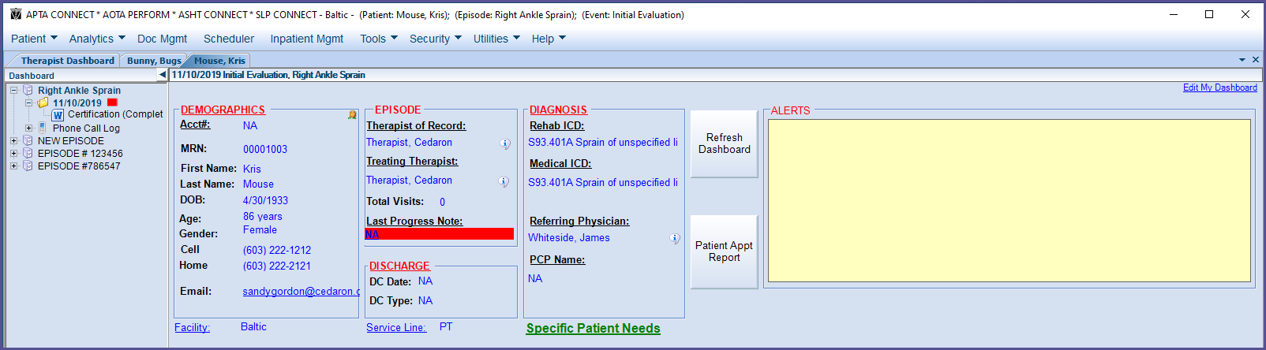

An Alerts box will open that allows the user to enter in free text.

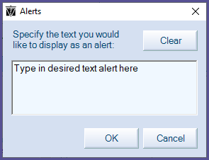

After the desired alert text is typed in, clicking **OK** will save the text in the alerts box.

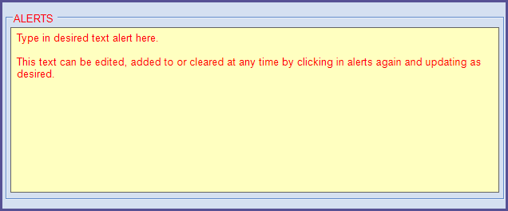

Further updates and edits can be made be made to this text at any time by clicking in the alerts box again.

The user created alerts will remain in the patient’s dashboard until they are manually cleared.

User created typed in alerts will not be part of the patient’s record and will not appear on reports.