 | ImpairmentCare Case Guide  Upper Extremity - Elbow Neuro Only 2

It is essential to look at the Impairment Details on an impairment case. The deficit numbers are the numbers we put into the calculator, and the percentage impairment is what we expect to get.

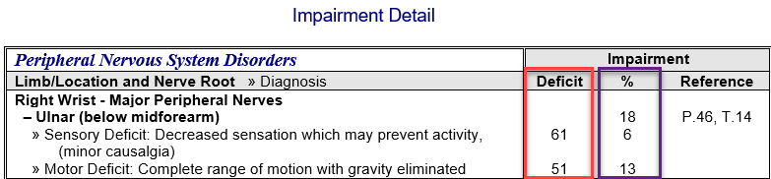
For the Elbow Neuro Only 2 case, we navigate to the Peripheral tab in the application because the disorder's name is shown in the Impairment Detail. Be sure to select the left or right option based on the Impairment Detail.

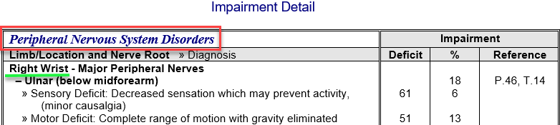

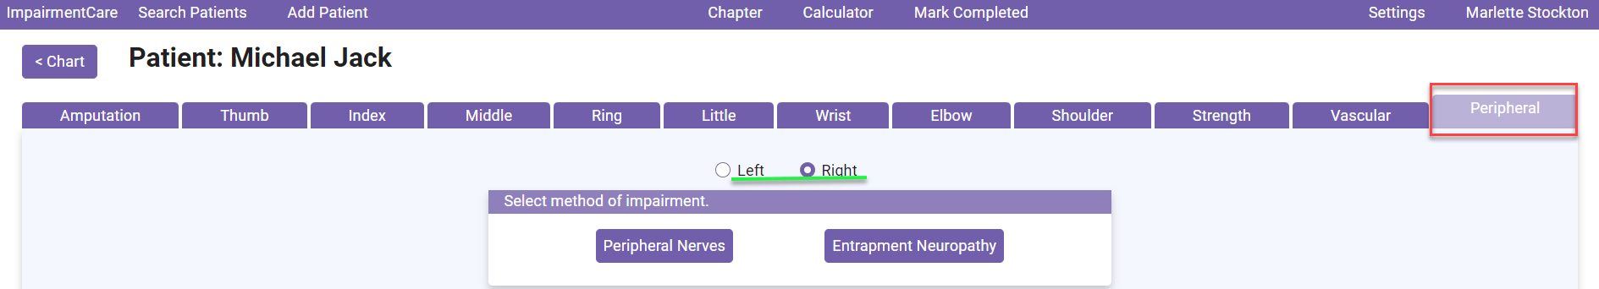

The peripheral nervous system is noted in the impairment detail, so the peripheral nerves are selected for the method of impairment.
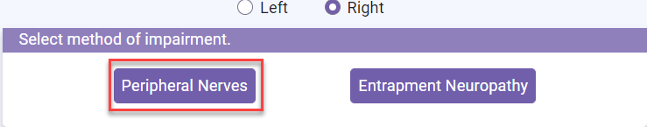

The first Impairment is noted at the Ulnar (below mid-forearm). This text is located on the Sensory and Motor Impairment chart within the application.

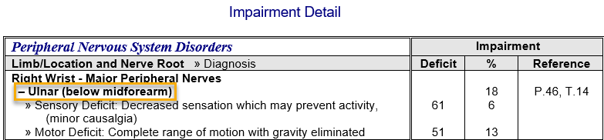

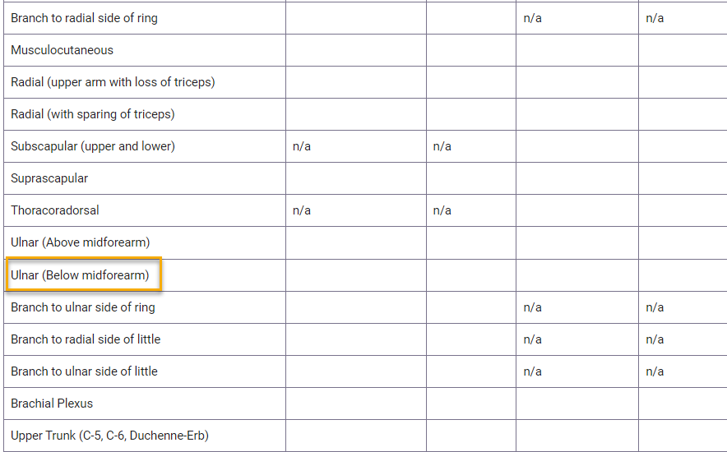

You will want to select a grade that will give you the closest % to the impairment. Each button represents a grade (describing the impairment), provides a range, and details the sensory or strength grade.

The Impairment below describes the Ulnar as » Sensory Deficit: Decreased sensation which may prevent activity (minor causalgia),» so we will select this grade, with a percentage of 61%.

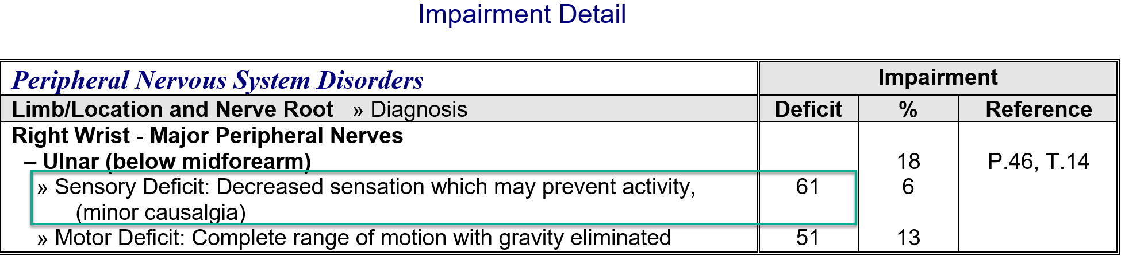

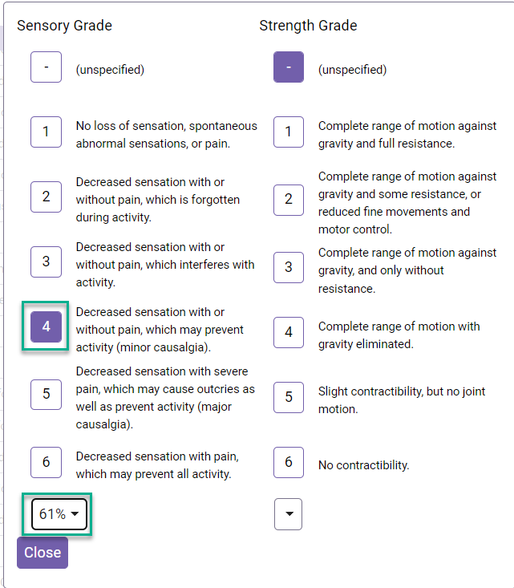

The next grade is » Motor Deficit: Complete range of motion with gravity eliminated. Select this for the strength grade, with a deficit of 51%.

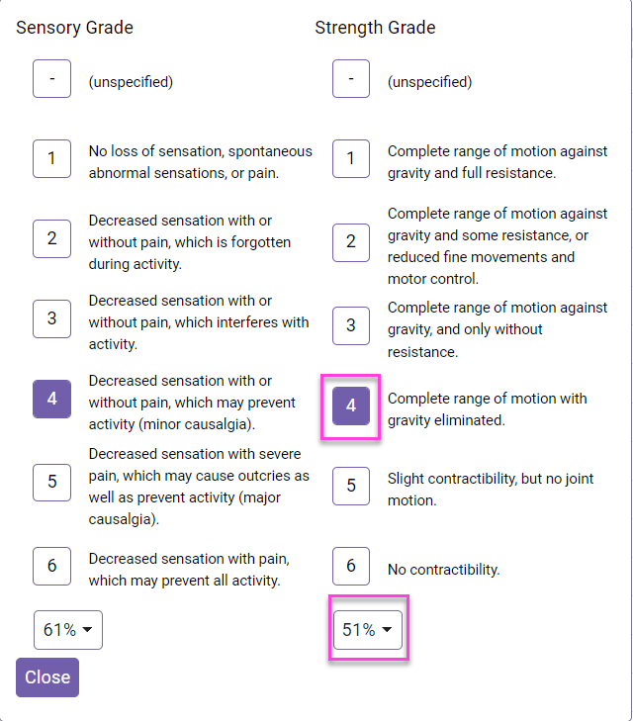

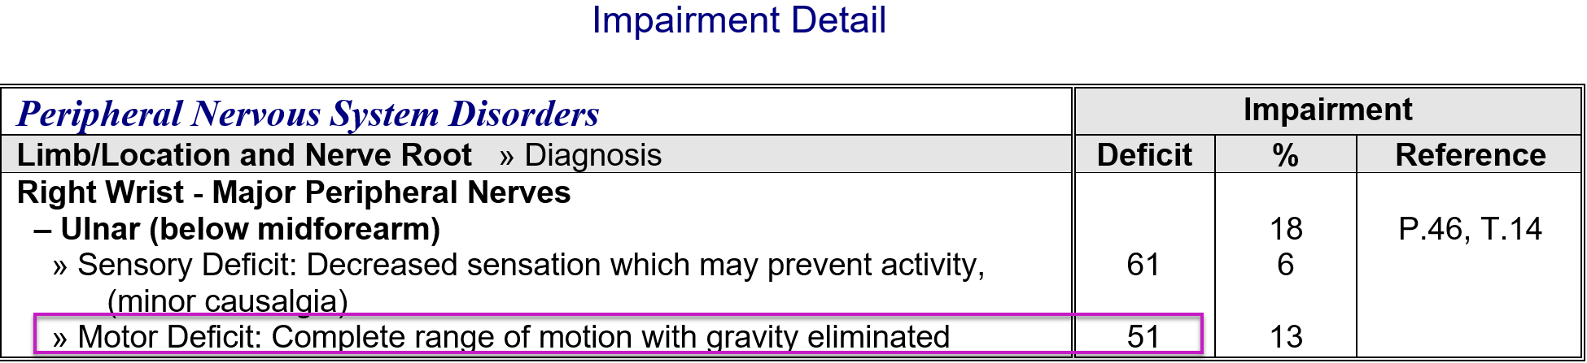

With the Sensory Deficit being 61% and the Motor deficit being 51%, we should have a percentage of 18%. We can check this by navigating to the whole person's Impairment under the calculator tab.

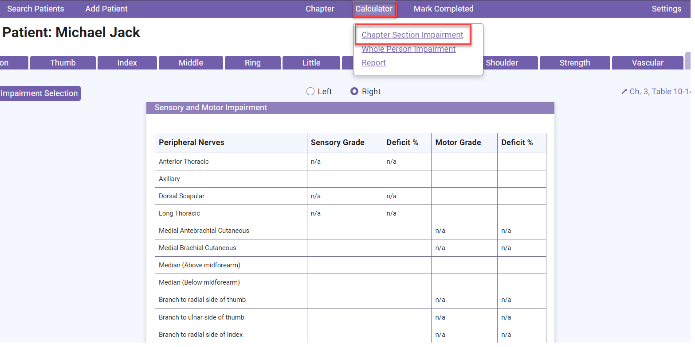

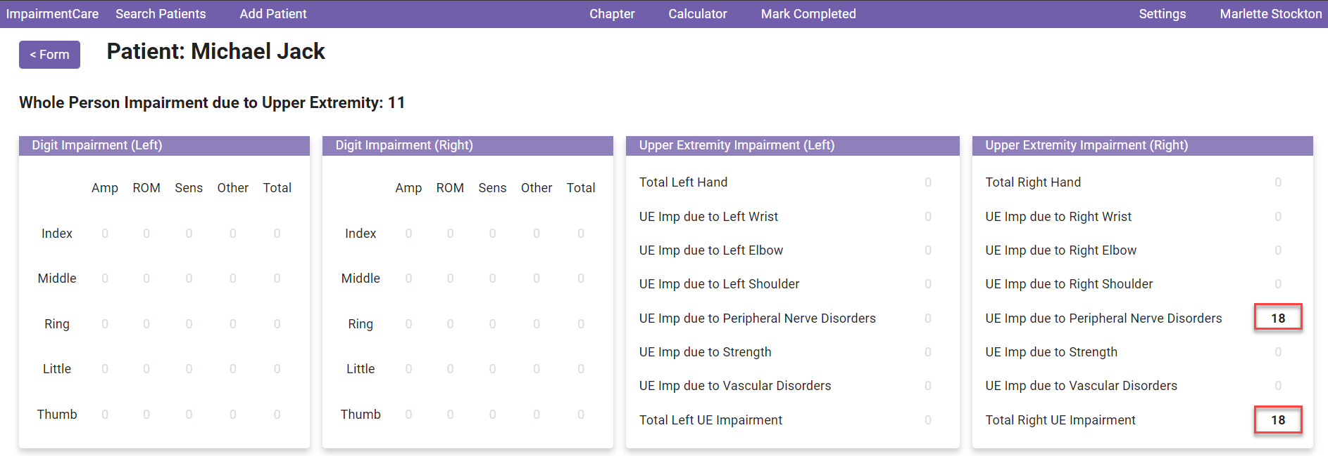

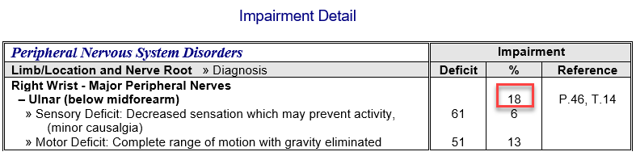

You can also view the whole-person Impairment, which is found under the calculator tab. Select Whole-Person Impairment.

